Settlement & Integration Services

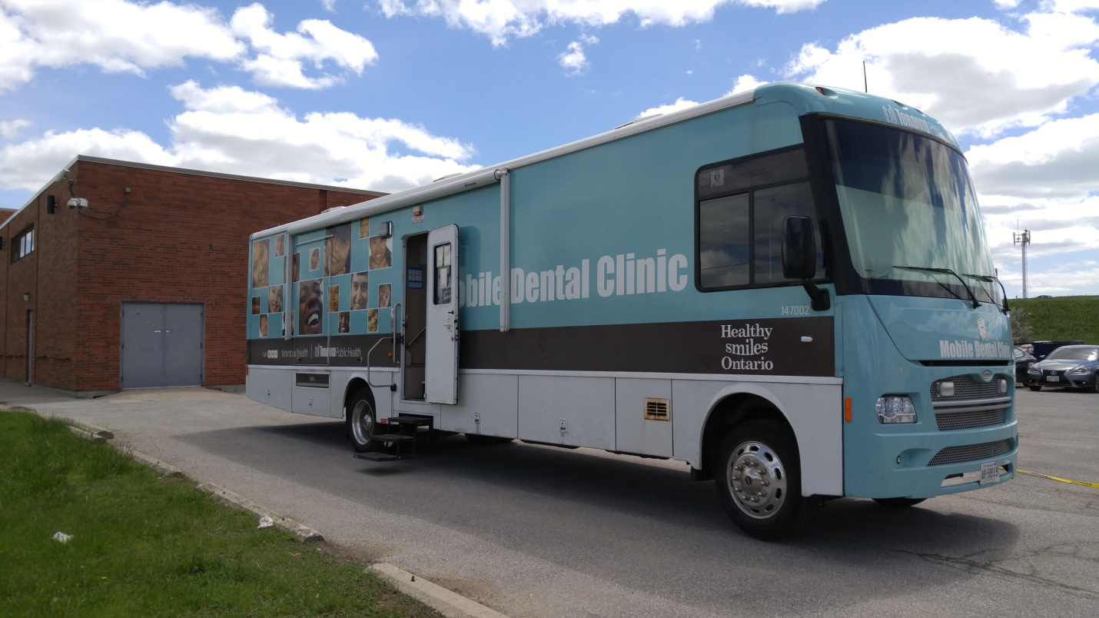

Toronto Public Health
Mobile Dental Clinic @ 2330 Midland Ave. (At Emblem Court)
CICS Immigrant Resource Centre
On February 26, 2018 (Monday)

Toronto Public Health eligibility requirements; client must:

- Have pain, abscess/infection, broken teeth/fillings
- Be on OW (Ontario Works) or ODSP (Ontario Disability Support Program)
- Provide current month's OW/ODSP statement/dental card as well as proof of address and date of birth
- Age between 18 to 64

Information and appointment booking: 416-292-7510 ext 0
.

TPH staff will go over the criteria of applicants who are required to complete necessary documents/paperwork to ensure they qualify for service and referral.

*New immigrants are requested to bring PR card or landing documents for attendance.*
For details of more events, visit www.cicscanada.com.

